BIG-BAG EMPTYING STATION
CONTACT DETAILS

Name and Surname: Click to enter name and surname.
Company Click to enter company.
Street: Click to enter street.
City: Click to enter city.
Country: Click to enter country.
Phone number: Click to enter phone number.
E-mail: Click to enter email address.
Date: Click to enter the date.

ORDER
The number of items: Click to enter the number of items.
MATERIAL
Material name: Click to enter material name.
Grain size [mm]: Click to enter grain size [mm].
Bulk density [kg/m3]: Click to enter bulk density.
Moisture content [%]: Click to enter moisture content [%].
Angle of repose [º]: Click to enter angle of repose [^{O}].
Material temperature [ºC]: ☐ 0-40 ☐ other: Click to enter other temperature [ºC].
Material features: ☐ well- flowing ☐ medium flowing ☐ difficult-flowing ☐ abrasive ☐ brittle ☐ stick ☐ compressible ☐ dusty ☐ easily aerating (“ uncontrolled flowing”) ☐ bridging ☐ higroscopic ☐ toxic ☐ chemically aggressive
REQUIREMENTS
Emptying capacity [kg/h]: Click to enter emptying capacity.
Number of BIG-BAGs per hour: Click to enter the number of BIG-BAGs per hour.
BIG-BAG INFORMATION
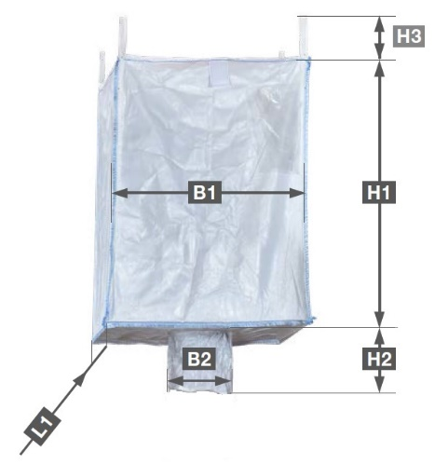
Number of handles: ☐ 0 ☐ 2 ☐ 4
Maximum weight [kg]: Click to enter maximum weight.
Dimensions:
B1 (bag length) [mm]: Click to enter B1.
B2 (spout diameter) [mm]: Click to enter B2.
H1 (bag height) [mm]: Click to enter H1.
H2 (spout height) [mm]: Click to enter H2.
H3 (height of handles) [mm]: Click to enter H3.
L1 (bag width) [mm]: Click to enter L1.

CONSTRUCTION
Space of installation
Length [mm]: Click to enter length.
Width [mm]: Click to enter width.
Height [mm]: Click to enter height.

Place of installation of the BIG-BAG emptying station
Click to enter BIG-BAG emptying station localization.
Configuration
☐ Docking station with massage plates and an integrated bag transporting system (gantry crane and electric chain hoist)
☐ Docking station with massage plates (transport of the bag with a forklift available at the plant)
☐ Docking station with massage plates (transport of the bag with a crane available at the plant)
☐ Other Click to enter other configuration
Additional device mounted under the emptying station for feeding the material
☐ not ☐ yes → ☐ screw conveyor
☐ rotary feeder
☐ knife gate valve
☐ pneumatic transport → ☐ vacuum transport ☐ overpressure transport
☐ feeder → ☐ volumetric screw feeeder ☐ gravimetric screw feeder
☐ belt weighfeeder ☐ vibrating feeder
☐ continous dosing ☐ batcg dosing

☐ Other: Click to enter additional device.
Frame
☐ carbon steel, powder coated with polyester paint, coating thickness 70-80 μm ☐ varnish class C5-I
☐ stainless steel 1.4301 (AISI304) ☐ stainless steel 1.4404 (AISI 316L)

Conponents with contact with the material
☐ stainless steel 1.4301 (AISI304) ☐ stainless steel 1.4404 (AISI 316L)
OPTIONAL: ☐ FDA compliant components
☐ hygienic version - internal surface grinding (Ra<0,8 µm), continuous internal and external welds
ENVIRONMENT
Working temperature [ºC]: ☐ maximum 40 ☐ other: Click to enter the other temperature.
ATEX: ☐ not ☐ yes → Gases, liquids and their vapors
Inside the device: ☐ 0 ☐ 1 ☐ 2
Outside the device: ☐ 1 ☐ 2
→ Explosive dusts:
Inside the device: ☐ 20 ☐ 21 ☐ 22
Outside the device: ☐ 21 ☐ 22 ☐ conductive dust (IIIC)
Dust explosion classification:
☐ ST1 ☐ ST2 ☐ ST3
Minimum ignition temperature [°C]
Click to enter minimum ignition temperature [ºc].
Minimum ignition energy [mJ].
Click to minimum ignition energy [mJ] .

ADDITIONAL OPTIONS
Weighing system: ☐ not ☐ yes
BIG-BAG emptying control system: ☐ not ☐ yes → TYPE OF INSTALLATION OF THE CONTROLER:: ☐ panel-mount
☐ in a stainless steel housing ☐ for installation in a control cabinet

ADDITIONAL COMMENTS
Comments:
Click to enter comments.

