GRAVIMETRIC SCREW FEEDER QUESTIONNAIRE
CONTACT DETAILS

Name and Surname: Click to enter name and surname.
Company Click to enter company.
Street: Click to enter street.
City: Click to enter city.
Country: Click to enter country.
Phone number: Click to enter phone number.
E-mail: Click to enter email address.
Date: Click to enter the date.

ORDER
The number of items: Click to enter the number of items.
MATERIAL
Material name: Click to enter material name.
Grain size [mm]: Click to enter grain size.
Bulk density [kg/m3]: Click to enter bulk density.
Moisture content [%]: Click to enter moisture content.
Angle of repose [º]: Click to enter angle of repose.
Material temperature [ºC]: ☐ 0-40 ☐ other: Click to enter other temperature.
Material features: ☐ well- flowing ☐ medium flowing ☐ difficult-flowing ☐ abrasive ☐ brittle ☐ stick ☐ compressible ☐ dusty ☐ easily aerating (“ uncontrolled flowing”) ☐ bridging
REQUIREMENTS
Feed rate [kg/h]: min.: Enter V min. max.: Enter V max.
Dosing mode ☐ continuous → maximum dosing error [% of set value]:
Click to enter dosing error in %.
☐ batch → maximum dosing error [kg, g]
Click to enter dosing error in kg, g.

CONSTRUCTION
Reffilling the hooper
☐ manual (hinged cover with a handle and a charging grate)
☐ automatic (inlet opening and connection to the dust extraction system)
Place of installation of the feeder e.g. under the Big-Bag emptying station, etc.
Click to enter the exact place of installation of the feeder.
Application of the feeder (e.g working as a separate device, in mixing lines, as an element of packaging system)
Click to enter the application of the feeder.
Execution
Components in contact with the material:
☐ stainless steel 1.4301 (AISI304) ☐ stainless steel 1.4404 (AISI 316L)
Components not in contact with the material:
☐ carbon steel, powder coated with polyester paint, coating thickness 70-80 μm ☐ stainless steel 1.4301 (AISI304)

MOTOR
☐ SEW gearmotor 3x400 V AC with protection degree IP65
☐ SEW gearmotor 3x500 V AC with protection degree IP65
☐ SEW gearmotor in aseptic version, protection degree IP66
☐ Other: Click to enter other type of motor.
Frequency [Hz]: 544
The motor is controlled by an inverter.

ENVIRONMENT
Working temperature [ºC]: ☐ maximum 40 ☐ Other: Click to enter the other temperature.
ATEX: ☐ not ☐ yes → Gases, liquids and their vapors
Inside the device: ☐ 0 ☐ 1 ☐ 2
Outside the device: ☐ 1 ☐ 2
→ Explosive dusts:
Inside the device: ☐ 20 ☐ 21 ☐ 22
Outside the device: ☐ 21 ☐ 22 ☐ conductive dust (IIIC)
Dust explosion classification:
☐ ST1 ☐ ST2 ☐ ST3
Minimum ignition temperature [°C]
Click to enter minimum ignition temperature [ºC].
Minimum ignition energy [mJ].
Click to enter ignition temperature [mJ].

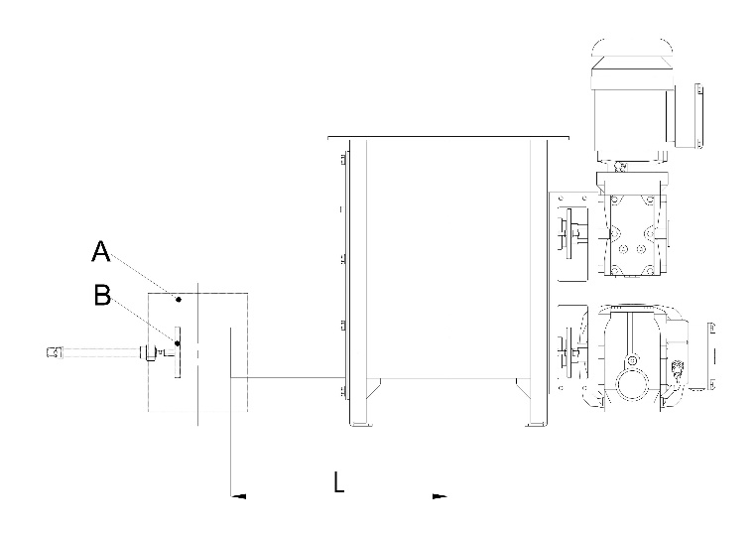
ADDITIONAL OPTIONS
Vertical outlet pipe (A):
☐ not ☐ yes
Material flow shut-off valve for batch (B):
☐ not ☐ yes
Extended outlet pipe:
☐ not ☐ yes → L [mm]: Click to enter L.

SYSTEM CONTROL
☐ With Control System ☐ Without Control System

Control Cabinet IP65
☒ powder- coated ☐ Stainless steel 1.4301 (AISI304)
☐ Other Click to enter type.

Control cabinet installation place: ☐ on screw feeder on left side
☐ on screw feeder on right side
☐ separately. The length of the cable routes [m]
Click to enter the length of the cable routes.
☐ in Client’s control cabinet. The length of the cable routes [m]
Click to enter the length of the cable routes.
Communication: ☐ Modbus TCP ☐ Modbus RTU ☐ Ethernet IP ☐ Profibus DP
ADDITIONAL COMMENTS
Comments:
Click to enter the additional comments.

