**DTU WEIGH BELT FEEDER QUESTIONNAIRE**

**CONTACT DETAILS**

Name and Surname: Click to enter name and surname.  
Company: Click to enter company.  
Street: Click to enter street.  
City: Click to enter city.  
Country: Click to enter country.  
Phone number: Click to enter phone number.  
E-mail: Click to enter e-mail address.  
Date: Click to enter the date.

Celu pucharse Darmowe ikony **ORDER**

The number of items: Click to enter the number of items.

** MATERIAL**

Material name: Click to enter material name.  
Grain size [mm]: Click to enter grain size [mm].  
Bulk density [kg/m3]: Click to enter bulk density.  
Moisture content [%]: Click to enter moisture content [%].  
Angle of repose [o]: Click to enter angle of repose[o].  
Material temperature [oC]:  0-40  other: Click to enter other temperature.  
Material features:  well- flowing  medium flowing  difficult-flowing  abrasive  brittle  stick  compressible  dusty  easily aerating (“ uncontrolled flowing”)  bridging  hygroscopic  toxic  chemically aggressive

Zatwierdza symbol Darmowe ikony **REQUIREMENTS**

Feed rate [kg/h]: min.: Enter V min. maks.: Enter V max.  
Dosing mode  continuous

→ maximum dosing error [% of set value]:

Click to enter dosing error [% set value].  
  batch

→ portion weight [kg]

Click to enter portion weight [kg].

→ number of portions per hour

Click to enter number of portions per hour.

→ maximum dosing error [kg,g]

Click to enter dosin error [kg,g].

measurement of flowing material

→ maximum dosing error [t,kg]

Click to enter dosing error [t,kg].

**C:\Users\Dziekan\Desktop\INTERPROCESS\zdalnie\INTERPROCESS\INTERPROCESS KARTY\ikony\konfiguracja-narzedzi-i-symboli_318-9134.jpg CONSTRUCTION**

Installation of feeder

under the hooper

using the prefedder →  rotary valve → prefeeder delivery  Client delivers prefeeder  screw feeder  InterProcess delivers prefeeder  weigh belt feeder  vibrating feeder  Other Click to enter type.

in the transport and production line (only for measuring material flow)

***How the material is transported to the feeder***

Click to enter how the material is transported to the feeder.

***Feeder localization***

Click to enter feeder localization

***Space limitations***

Length[mm]: Click to enter length.  
Width [mm]: Click to enter width.  
Height [mm]: Click to enter height.

***Required weigh length [mm]:***  300  600

***Feeder version:***

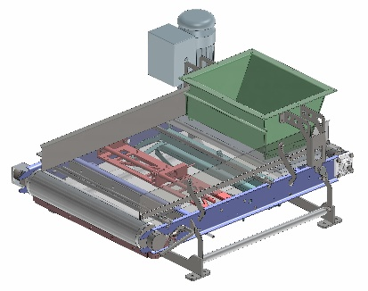without housing  in dust-proof housing

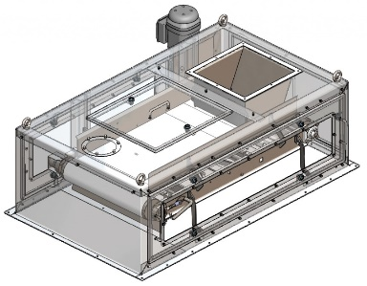

***Execution***

stainless steel 1.4301 (AISI304)  stainless steel 1.4404 (AISI 316L)

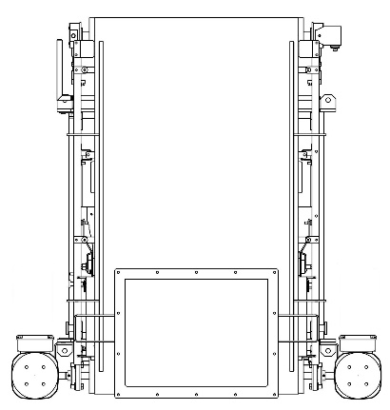 **MOTOR**

Outlet

SEW gearmotor with protection degree IP65

SEW gearmotor in aseptic version, protection degree IP66

Other: Click to enter other type of motor.

Frequency [Hz]: Click to enter frequency.

***The motor is controlled by an inverter.***

***Gearmotor location***

Left side

Right side

Right side

Left side

Inlet

Jasność Darmowe ikony **ENVIRONMENT**

Working temperature [oC]:  maximum 40  other: Click to enter the other temperature.  
ATEX:  not  yes → Gases, liquids and their vapors  
 Inside the device:  0  1  2  
 Outside the device:  1  2

→ Explosive dusts:  
 Inside the device:  20  21  22  
 Outside the device:  21  22  conductive dust (IIIC)

Dust explosion classification:

ST1  ST2  ST3

Minimum ignition temperature [°C]

Click to enter minimum ignition temperature [oc].

Minimum ignition energy [mJ].

Click to enter minimum ignition energy [mJ].

Kalkulator Darmowe ikony **SYSTEM CONTROL**

Without Control System  Control system with range linearization

Control Cabinet IP65  
 powder- coated  Stainless steel 1.4301 (AISI304)

Other Click to enter type.

Control cabinet installation place:  on screw feeder on left side

on screw feeder on right side

separately. The length of the cable routes [m]

Click to enter the length of cable routes.

in Client’s control cabinet. The length of the cable routes [m]

Click to enter the length of cable routes.  
Communication:  Modbus TCP  Modbus RTU  Ethernet IP  Profibus DP

** ADDITIONAL COMMENTS**

Comments:

Click to enter comments.