BELT SCALE QUESTIONNAIRE
CONTACT DETAILS

Name and Surname: Click to enter name and surname
Company Click to enter company
Street: Click to enter street
City: Click to enter the city
Country: Click to enter country
Phone number: Click to enter phone number
E-mail: Click to enter an e-mail address
Date: Click to enter the date

ORDER
The number of items: Click to enter the number of items

MATERIAL
Material name: Click to enter material name
Grain size [mm]: Click to enter grain size [mm]
Bulk density [kg/m3]: Click to enter bulk density
Moisture content [%]: Click to enter moisture content [%]
Embankment angle[º]: Click to enter embankment angle [º]:
Material temperature [ºC]: ☐ 0-40 ☐ other: Click to enter other temperature [ºC]
Material features: ☐ well- flowing ☐ medium flowing ☐ difficult-flowing ☐ abrasive ☐ brittle ☐ stick ☐ compressible ☐ dusty ☐ easily aerating (“ uncontrolled flowing”) ☐ bridging ☐ hygroscopic ☐ toxic ☐ chemically aggressive
ENVIRONMENT
Working temperature [ºC]: ☐ maximum 50 ☐ other: Click to enter other temperature
ATEX: ☐ not ☐ yes → Gases, liquids and their vapors
☐ 0 ☐ 1 ☐ 2
→ Explosive dusts:
☐ 20 ☐ 21 ☐ 22

WEIGHT
Technological: ☐ not ☐ yes
Legal-for-trade: ☐ not ☐ yes → Class: ☐ 0,5 ☐ 1 ☐ 2
Execution: ☐ carbon steel powder coated polyester paint (standard) ☐ C5-I paint class
☐ stainless steel 304 ☐ galvanized steel

CONVEYOR (if possible, please attach a technical drawing or/and remove the conveyor)

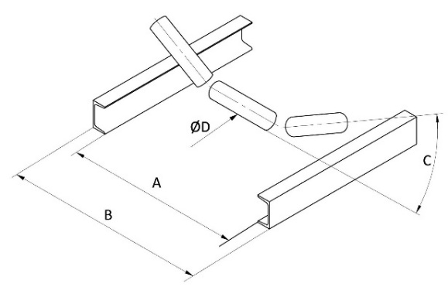
Attached technical drawing or/and removal of conveyor: ☐ not ☐ yes
Application type: ☐ flow measurement ☐ flow regulation ☐ dosing- batching
Weighing accuracy required [%]: Click to enter weighing accuracy
Efficiency[kg/m]/[kg/s]: Click to enter efficiency → constant efficiency: ☐ not ☐ yes
Belt speed [m/s]: Click to enter belt speed
Belt width [mm]: Click to enter belt width
Belt length [m]: Click to enter belt length
Belt thickness[mm]: Click to enter belt thickness
Belt execution: ☐ flat ☐ side frills ☐ cross frills
Inclination angle of conveyor [º]: Click to enter inclination angle of conveyor
Distance between rollers [mm Click to enter distance between rollers
Shape of the roller shape: ☐ flat ☐ U-shaped ☐ V-shaped
Tape tension: ☐ gravimetric ☐ screw ☐ spring
Support structure of conveyor: ☐ garland ☐ tubular ☐ with C-profiles ☐ ac ☐ twisted ☐ welded ☐ movable construction
Conveyor sheltered: ☐ not ☐ yes
Dimension A [mm]: Enter A Dimension B [mm]: Enter B Rollers inclination angle C [º]: Enter C diameter of idler ØD [mm]: Enter D

CONTROL SYSTEM

Type of controller installation: ☐ wall-mounted ☐ array ☐ for strip DIN
Distance from scale to the controller [m] Enter the distance from the scale to the controller [m].

Communication: ☐ Modbus TCP ☐ Modbus RTU ☐ Ethernet IP ☐ Profibus DP
ADDITIONAL COMMENTS
Comments:
Click to enter comments

