VOLUMETRIC SCREW FEEDER QUESTIONNAIRE
CONTACT DETAILS

Name and Surname: Click to enter name and surname.
Company Click to enter company.
Street: Click to enter street.
City: Click to enter city.
Country: Click to enter country.
Phone number: Click to enter phone number.
E-mail: Click to enter email address.
Date: Click to enter the date.

 ORDER
The number of items: Click to enter the number of items.
 MATERIAL
Material name: Click to enter material name.
Grain size [mm]: Click to enter grain size.
Bulk density [kg/m3]: Click to enter bulk density.
Moisture content [%]: Click to enter moisture content.
Angle of repose [º]: Click to enter angle of repose.
Material temperature [ºC]: ☐ 0 ÷ 40 ☐ other: Click to enter other temperature.
Material description: ☐ well- flowing ☐ medium flowing ☐ difficult-flowing ☐ abrasive ☐ fragile ☐ sticky ☐ cohesive ☐ dusty ☐ easily aerating (“ uncontrolled flowing”) ☐ bridging, ratholing
 REQUIREMENTS
Feed rate [kg/h]: min.: Enter V min. max.: Enter V max.
Dosing mode: ☐ continuous ☐ batch

 CONSTRUCTION
Reffilling the hooper
☐ manual (hinged cover with a handle and a safety grate)
☐ automatic (two round spigots, for material refill and ventilation)
Place of installation of the feeder e.g. under a Big-Bag emptying station, under a buffer hopper etc.
Click to enter the exact place of installation of the feeder.
Application description (e.g working as a separate device, in mixing lines, as an element of packaging system etc.)
Click to enter the application of the feeder.
Execution
Components in contact with the material:
☐ stainless steel 1.4301 (AISI304) ☐ stainless steel 1.4404 (AISI 316L)
Design
☐ standard – steel surfaces electropolished or bead-blasted, continous internal weld seams, non-steel components in contact with the material FDA-certified
☐ hygienic - continuous internal and external welds, non-steel components in contact with the material FDA-certified, steel surfaces in contact with the material ground (Ra<0.8μm) and electropolished, internal weld seams ground; gearmotors in aseptic version (does not apply to ATEX version); support frame in easy-to-clean design; Rittal HD series enclosures

 MOTOR
☐ SEW gearmotor 3x400 V AC with protection degree IP65
☐ SEW gearmotor 3x500 V AC with protection degree IP65
☐ SEW gearmotor in aseptic version, protection degree IP66
☐ Other: Click to enter other type of motor.
Frequency [Hz]: Click to enter frequency.
The feeding device’s gearmotor is controlled by an inverter.

 ENVIRONMENT
Ambient temperature [ºC]: ☐ 0 ÷ 40 ☐ Other: Click to enter the other temperature.
ATEX (explosion risk zone): ☐ no ☐ yes → Gases, liquids and their vapors
Inside the device: ☐ 0 ☐ 1 ☐ 2
Outside the device: ☐ 1 ☐ 2
→ Explosive dusts:
Inside the device: ☐ 20 ☐ 21 ☐ 22
Outside the device: ☐ 21 ☐ 22 ☐ conductive dust (IIIC)
Dust explosion classification:
☐ ST1 ☐ ST2 ☐ ST3
Minimal ignition temperature [°C]
Click to enter minimum ignition temperature [ºC].
Minimal ignition energy [mJ].
Click to enter ignition temperature [mJ].
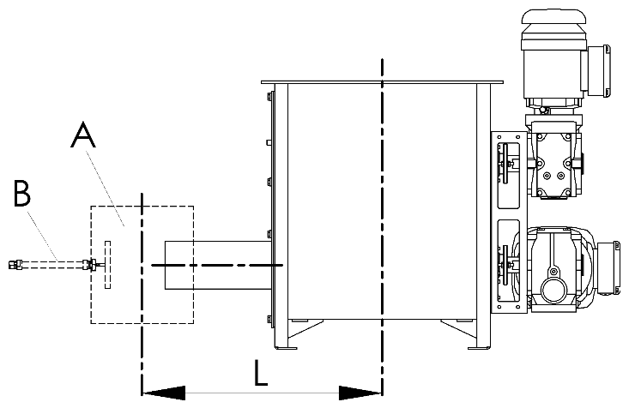
 ADDITIONAL OPTIONS
Vertical outlet pipe (A):
☐ no ☐ yes

Material flow shut-off valve for batch feeding that improves batch accuracy and repeatability (B):
☐ no ☐ yes

Extended outlet pipe:
☐ no ☐ yes → L [mm]: Click to enter L.

 SYSTEM CONTROL
☐ With Control System ☐ Without Control System

RITTAL Control Cabinet IP65
☐ Powder- coated RAL 7035 ☐ Stainless steel 1.4301 (AISI304)
☐ Other Click to enter type.

Control cabinet installation place: ☐ on the feeder (left side)
☐ on the feeder (right side)
☐ separately. The length of the cable routes [m]
Click to enter the length of the cable routes.
☐ in Client’s control cabinet. The length of the cable routes [m]
Click to enter the length of the cable routes.
Fieldbus: ☐ Modbus TCP ☐ Modbus RTU ☐ EthernetIP ☐ Profibus DP ☐ Profinet

 ADDITIONAL COMMENTS
Comments:
Click to enter the additional comments.

