BIG-BAG EMPTYING STATION
CONTACT DETAILS

Name and Surname: Click to enter name and surname.
Company Click to enter company.
Street: Click to enter street.
City: Click to enter city.
Country: Click to enter country.
Phone number: Click to enter phone number.
E-mail: Click to enter email address.
Date: Click to enter the date.

 ORDER
The number of items: Click to enter the number of items.
 MATERIAL
Material name: Click to enter material name.
Grain size [mm]: Click to enter grain size [mm].
Bulk density [kg/m3]: Click to enter bulk density.
Moisture content [%]: Click to enter moisture content [%].
Angle of repose [º]: Click to enter angle of repose [^{O}].
Material temperature [ºC]: ☐ 0÷40 ☐ other: Click to enter other temperature [ºC].
Material features: ☐ well- flowing ☐ medium flowing ☐ difficult-flowing ☐ abrasive ☐ fragile ☐ sticky ☐ cohesive ☐ dusty ☐ easily aerating (“ uncontrolled flowing”) ☐ bridging, ratholing ☐ hygroscopic ☐ toxic ☐ chemically aggressive
REQUIREMENTS
Emptying capacity [kg/h]: Click to enter emptying capacity.
Number of BIG-BAGs per hour: Click to enter the number of BIG-BAGs per hour.
 BIG-BAG INFORMATION
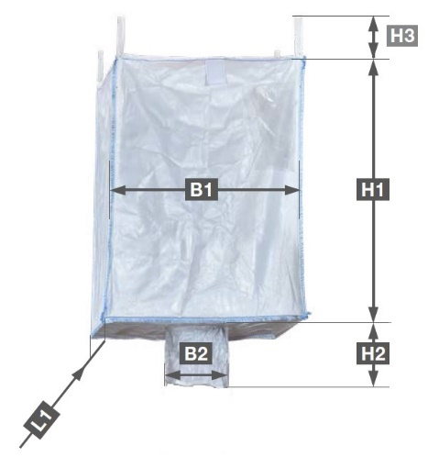
Number of handles: ☐ 0 ☐ 2 ☐ 4
Maximum weight [kg]: Click to enter maximum weight.
Dimensions:
B1 (bag length) [mm]: Click to enter B1.
B2 (spout diameter) [mm]: Click to enter B2.
H1 (bag height) [mm]: Click to enter H1.
H2 (spout height) [mm]: Click to enter H2.
H3 (height of handles) [mm]: Click to enter H3.
L1 (bag width) [mm]: Click to enter L1.

 CONSTRUCTION
Space of installation
Length [mm]: Click to enter length.
Width [mm]: Click to enter width.
Height [mm]: Click to enter height.

Place of installation of the BIG-BAG emptying station
Click to enter BIG-BAG emptying station localization.
Sealing of the BIG-BAG’s spout
☐ Docking module (spout sealed by mechanical clamping, ensures dust-free unloading)
☐ Docking module with an inflatable seal (provides even greater assurance of dust-free unloading)
☐ Other Click to enter type.
Method of delivering BIG-BAGs to the station
☐ Integrated bag transport system ( crane and electric chain hoist)
☐ Installation of the bag at the station using a forklift truck
☐ Installation of the bag at the station using an overhead crane available at the site (crane occupied during unloading)
Method of assisting the unloading of bags
☐ Bag massaging module using pneumatic cylinders (good for materials difficult to unload)
OPTION: ☐ Additional side boxers (recommended for materials that are extremely difficult to unload)
☐ Resting table (recommended only for well-flowing materials, such as granules)
OPTION: ☐ Electric vibrator on resting table
☐ Other Click to enter type.
Additional device mounted under the emptying station for feeding the material
☐ no ☐ yes → ☐ screw conveyor
☐ rotary feeder
☐ knife gate valve
☐ pneumatic transport → ☐ vacuum transport ☐ overpressure transport
☐ feeder → ☐ volumetric screw feeeder ☐ gravimetric screw feeder
☐ belt weighfeeder ☐ vibrating feeder
☐ continous dosing ☐ batch dosing

☐ Other: Click to enter additional device.
Frame
☐ carbon steel, powder coated with polyester paint, coating thickness 70-80 μm ☐ coating category C5-I
☐ stainless steel 1.4301 (AISI304) ☐ stainless steel 1.4404 (AISI 316L)

Conponents with contact with the material
☐ stainless steel 1.4301 (AISI304) ☐ stainless steel 1.4404 (AISI 316L)
OPTION: ☐ FDA non-steel compliant components
☐ hygienic execution → ☐ continuous internal and external welds
☐ easy-to-clean construction (minimization of zones that accumulate dust)
☐ grinding of internal surfaces to a roughness level Ra < 0.8µm
☐ Rittal HD series electrical enclosures (Hygienic Design)

 ENVIRONMENT
Ambient temperature [ºC]: ☐ 0÷40 ☐ other: Click to enter the other temperature.
Ex – explosive atmosphere zone: ☐ no ☐ yes → Gases, liquids and their vapors
Inside the device: ☐ 0 ☐ 1 ☐ 2
Outside the device: ☐ 1 ☐ 2
→ Explosive dusts:
Inside the device: ☐ 20 ☐ 21 ☐ 22
Outside the device: ☐ 21 ☐ 22 ☐ conductive dust (IIIC)
Dust explosion classification:
☐ ST1 ☐ ST2 ☐ ST3
Minimum ignition temperature [°C]
Click to enter minimum ignition temperature [ºc].
Minimum ignition energy [mJ].
Click to minimum ignition energy [mJ] .

 ADDITIONAL OPTIONS
Weighing system: ☐ no ☐ yes
BIG-BAG emptying control system: ☐ no ☐ yes → PLACE OF INSTALLATION OF THE CONTROLLER AND INSTRUMENTS: ☐ on the station structure
☐ outside the station Click to enter the length of the cable routes.
☐ in the customer's control cabinet Click to enter the length of the cable routes.

IP65 control cabinet:
☐ powder coated ☐ made of 1.4301 (AISI304) stainless steel
☐ other Click to enter type.

 ADDITIONAL COMMENTS
Comments:
Click to enter comments.

