BIG BAG FILLING STATION
CONTACT DETAILS

Name and Surname: Click to enter name and surname.
Company Click to enter company.
Street: Click to enter street.
City: Click to enter city.
Country: Click to enter country.
Phone number: Click to enter phone number.
E-mail: Click to enter email address.
Date: Click to enter the date.

 ORDER
The number of items: Click to enter the number of items.

 MATERIAL
Material name: Click to enter material name.
Grain size [mm]: Click to enter grain size.
Bulk density [kg/m3]: Click to enter bulk density.
Moisture content [%]: Click to enter moisture content.
Angle of repose [º]: Click to enter angle of repose.
Material temperature [ºC]: ☐ 0-40 ☐ other: Click to enter other temperature.
Material description: ☐ well- flowing ☐ medium flowing ☐ difficult-flowing ☐ abrasive ☐ brittle ☐ stick ☐ compressible ☐ dusty
☐ easily aerating (“ uncontrolled flowing”) ☐ bridging
☐hygroscopic ☐ toxic ☐chemically aggressive

 REQUIREMENTS
Filling capacity [kg/h]: Click to enter filling capacity.
Number of BIG-BAGs per hour Click to enter number of BIG-BAGs per hour.

 BIG-BAG INFORMATION
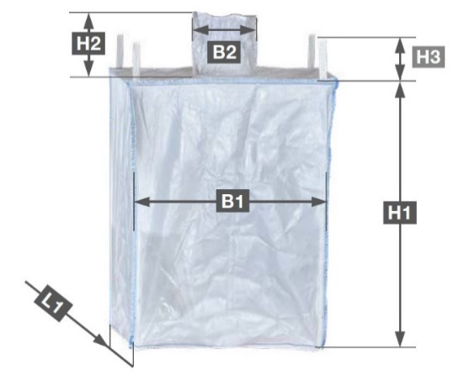
Number of holders: ☐ 0 ☐ 2 ☐ 4
Maximum weight [kg]: Click to enter maximum weight.
Dimensions:
B1 (bag length) [mm]: Click to enter B1.
B2 (spout diameter) [mm]: Click to enter B2.
H1 (bag height) [mm]: Click to enter H1.
H2 (spout height) [mm]: Click to enter H2.
H3 (height of handles) [mm]: Click to enter H3.
L1 (bag width) [mm]: Click to enter L1.

 CONSTRUCTION
Space of installation
Length [mm]: Click to enter length.
Width [mm]: Click to enter width.
Height [mm]: Click to enter height.

Place of installation of the BIG-BAG filling station
Click to enter the BIG-BAG filling station localization.
Additional device mounted above the filling station for feeding the material (if not delivered by the customer and should be included in the offer).
☐ no ☐ yes → ☐ rotary feeder ☐ belt weigh feeder☐ butterfly valve
☐ screw conveyor ☐ vibrating feeder ☐ volumetric screw feeder
☐ knife gate valve
☐ Other: Click to enter additional device.
Frame execution
☐ carbon steel, powder coated with polyester paint, coating thickness > 70÷80 μm ☐ coating class C5-I
☐ stainless steel 1.4301 (AISI304) ☐ stainless steel 1.4404 (AISI 316L)

Components in contact with the material
☐ stainless steel 1.4301 (AISI304) ☐ stainless steel 1.4404 (AISI 316L)
OPTIONAL:
☐ FDA compliant components
☐ hygienic version - internal surfaces ground (Ra<0,8 µm); continuous internal and external welds; construction easy to clean

 ENVIRONMENT
Ambient temperature [ºC]: ☐ 0-40 ☐ Other: Click to enter the other temperature.
ATEX: ☐ no ☐ yes → Gases, liquids and their vapors
Inside the device: ☐ 0 ☐ 1 ☐ 2
Outside the device: ☐ 1 ☐ 2
→ Explosive dusts:
Inside the device: ☐ 20 ☐ 21 ☐ 22
Outside the device: ☐ 21 ☐ 22 ☐ conductive dust (IIIC)
Dust explosion classification:
☐ ST1 ☐ ST2 ☐ ST3
Minimum ignition temperature [°C]
Click to enter minimum ignition temperature [ºC].
Minimum ignition energy [mJ].
Click to enter ignition temperature [mJ].

 ADDITIONAL OPTIONS
Big-Bag pre-forming device before filling process (makes preparing a big bag faster and easier):
☐ no ☐ yes

Automatically opened big-bag holders:
☐ no ☐ yes

Automatic tensioning of big-bags (optimizes filling process and distribution of the material inside a big-bag):
☐ no ☐ yes

Vibratory compacting device (optimizes filling process and distribution of the material inside a big-bag):
☐ no ☐ yes

 SYSTEM CONTROL
Weighing system: ☐ no ☐ yes → ☐ With filling control system ☐ Without filling control system

RITTAL Control Cabinet IP65
☐ Powder- coated RAL 7035 ☐ Stainless steel 1.4301 (AISI304)
☐ Other Click to enter type.

Control cabinet installation place: ☐ on the frame
☐ separately. The length of the cable routes [m]
Click to enter the length of the cable routes.
☐ in Client’s control cabinet. The length of the cable routes [m]
Click to enter the length of the cable routes.
Communication: ☐ Modbus TCP ☐ Modbus RTU ☐ Ethernet IP ☐ Profibus DP ☐ Profinet

 ADDITIONAL COMMENTS
Comments:
Click to enter additional comments.

