DTU WEIGH BELT FEEDER QUESTIONNAIRE
CONTACT DETAILS

Name and Surname: Click to enter name and surname.
Company: Click to enter company.
Street: Click to enter street.
City: Click to enter city.
Country: Click to enter country.
Phone number: Click to enter phone number.
E-mail: Click to enter e-mail address.
Date: Click to enter the date.

 ORDER
The number of items: Click to enter the number of items.

 MATERIAL
Material name: Click to enter material name.
Grain size [mm]: Click to enter grain size [mm].
Bulk density [kg/m3]: Click to enter bulk density.
Moisture content [%]: Click to enter moisture content [%].
Angle of repose [º]: Click to enter angle of repose[º].
Material temperature [ºC]: ☐ 0-40 ☐ other: Click to enter other temperature.
Material features: ☐ free- flowing ☐ medium flowing ☐ difficult-flowing ☐ abrasive ☐ brittle ☐ stick ☐ compressible ☐ dusty ☐ easily aerating (“ uncontrolled flowing”) ☐ bridging ☐ hygroscopic ☐ toxic ☐ chemically aggressive
 REQUIREMENTS
Feed rate [kg/h]: min.: Enter V min. maks.: Enter V max.
Dosing mode ☐ continuous
→ maximum dosing error [% of set value]:
Click to enter dosing error [% set value].
☐ batch
→ portion weight [kg]
Click to enter portion weight [kg].
→ number of portions per hour
Click to enter number of portions per hour.
→ maximum dosing error [kg,g]
Click to enter dosin error [kg,g].
☐ measurement of flowing material
→ maximum error [%]
Click to enter dosing error [t,kg].
 CONSTRUCTION
Installation conditions for the device:
☐ under a hooper
☐ using a prefeeder → ☐ rotary valve → prefeeder delivery ☐ Client delivers prefeeder ☐ screw feeder ☐ InterProcess delivers prefeeder ☐ weigh belt feeder ☐ vibrating feeder ☐ Other Click to enter type.
☐ in the transport and production line (only for measuring material flow)

How the material is transported to the feeder
Click to enter how the material is transported to the feeder.

Feeder localization
Click to enter feeder localization

Space limitations
Length[mm]: Click to enter length.
Width [mm]: Click to enter width.
Height [mm]: Click to enter height.
Required belt length [mm]: ☐ 300 ☐ 600
Feeder version:
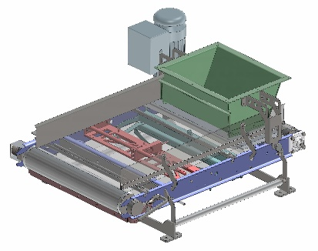
☐ without housing ☐ in a dust-proof housing
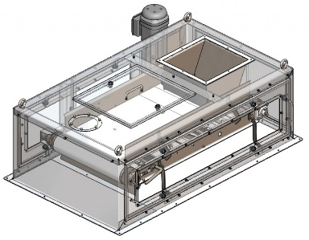

Execution
☐ stainless steel 1.4301 (AISI304) ☐ stainless steel 1.4404 (AISI 316L)
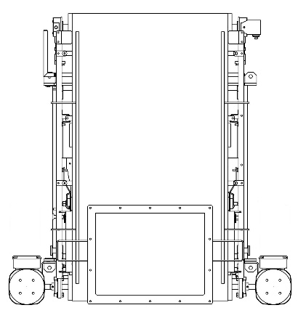
 MOTOR
Outlet
☐ SEW gearmotor with protection degree IP65
☐ SEW gearmotor in aseptic version, protection degree IP66
☐ Other: Click to enter other type of motor.
Frequency [Hz]: Click to enter frequency.
The motor is controlled by an inverter.
Gearmotor and scale control box installation side:
☐ Left side ☐
Inlet
☐ Right side
Right side
Left side

 ENVIRONMENT
Ambient temperature [ºC]: ☐ 0- 40 ☐ other: Click to enter the other temperature.
ATEX: ☐ no ☐ yes → Gases, liquids and their vapors
Inside the device: ☐ 0 ☐ 1 ☐ 2
Outside the device: ☐ 1 ☐ 2
→ Explosive dusts:
Inside the device: ☐ 20 ☐ 21 ☐ 22
Outside the device: ☐ 21 ☐ 22 ☐ conductive dust (IIIC)
Dust explosion classification:
☐ ST1 ☐ ST2 ☐ ST3
Minimum ignition temperature [°C]
Click to enter minimum ignition temperature [ºc].
Minimum ignition energy [mJ].
Click to enter minimum ignition energy [mJ].

 SYSTEM CONTROL
Weighing System ☐ no ☐ Yes → ☐With filling control system ☐Without filling control system

RITTAL Control Cabinet IP65
☐ powder- coated RAL 7035 ☐ Stainless steel 1.4301 (AISI304)
☐ Other Click to enter type.

Control cabinet installation place: ☐ on the frame

☐ separately. The length of the cable routes [m]
Click to enter the length of the cable routes.
☐ in Client’s control cabinet. The length of the cable routes [m]
Click to enter the length of the cable routes.
Communication: ☐ Modbus TCP ☐ Modbus RTU ☐ Ethernet IP ☐ Profibus DP ☐Profinet

 ADDITIONAL COMMENTS
Comments:
Click to enter comments.

